Project Profile

Project Type | Web Application
Project Title | Password Generator
Tech Stack | - HTML  - CSS/SCSS  - TypeScript/JavaScript
Deployment Platform | Github Pages

Project Introduction
In this exercise, we developed a prototype password generator to explore and validate the design choices involved in creating secure, user-friendly passwords. While the implementation is not intended for production use, it serves as a minimum viable product (MVP) for testing core functionality, usability, and security considerations. This approach allows us to analyze trade-offs, evaluate effectiveness, and draw insights that are relevant to software design and management.

System Overview
Purpose:
The system is a password generator prototype designed to produce customizable passwords for demonstration and validation purposes. Its goal is to explore usability, flexibility, and basic security features in a simple software context.
Key Components:
- Input Module – Allows the user to select password length, inclusion of letters, numbers, symbols, and case sensitivity.
- Character Pools – Predefined sets of characters (uppercase, lowercase, numbers, symbols) used for password construction.
- Password Generation Engine – Randomly selects characters from chosen pools and assembles them into a password.
- Output Module – Displays the generated password to the user and optionally allows regeneration.
Workflow:
- The user specifies preferences via the input module.
- The generation engine validates inputs and randomly constructs a password according to selected options.
- The output module presents the password and logs generation for validation/testing purposes.
Status & Scope:
- Functioning as an MVP/prototype, the system is suitable for testing and validation but is not production-ready.
- Focus is on demonstrating design decisions, usability, and password variability rather than full-scale security enforcement.

Proposed System
Objectives:
- Demonstrate Feasibility of the Password Generator
  - Show that a modular, customizable password generation system can be implemented as a working prototype.
  - Validate that the core functionality (length, character type selection, randomness) works as intended.
- Perform Technical Testing and Validation
  - Evaluate password strength using entropy (bits) and estimated crack time metrics.
  - Assess usability, responsiveness, and correctness of the system under different input scenarios.
- Analyze Security Implications
  - Examine how design choices (character sets, length, randomness source) affect password strength.
  - Provide qualitative ratings (Very Weak → Very Strong) to support validation results.
- Demonstrate Modular and Maintainable Design
  - Highlight separation of responsibilities across modules (generator, stats, UI).
  - Ensure that the system is extendable for additional features without modifying core logic.
- Provide Insights for Software Management Decisions
  - Use the prototype as a case study for evaluating trade-offs between usability, complexity, and security.
  - Showcase how testing and validation inform future improvements or production readiness.

Project Mockup
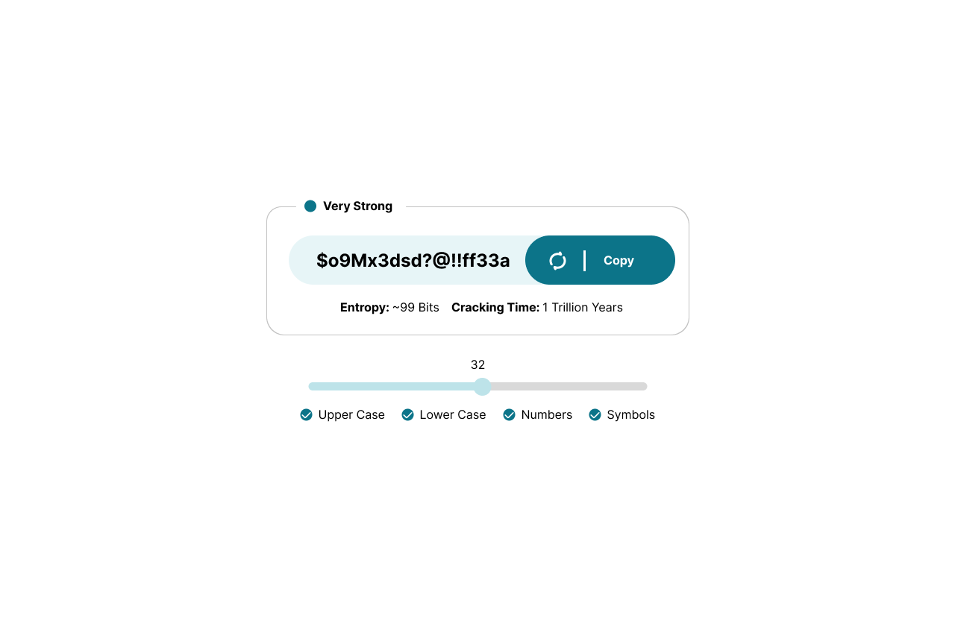

Testing & Recommandation
Testing Approach:
The password generator prototype underwent manual testing to validate functionality, usability, and security metrics. Tests included:
- Functionality Testing
  - Generated passwords of varying lengths and character types.
  - Verified inclusion of selected character sets in all generated passwords.
  - Tested UI features: slider adjustments, checkbox selections, refresh, and copy-to-clipboard.
- Security Metrics Testing
  - Calculated entropy (bits) and estimated crack time for different password configurations.
  - Confirmed that longer passwords with diverse character sets consistently resulted in higher entropy and stronger passwords.
- Usability Testing
  - Observed interface clarity, responsiveness, and intuitiveness during manual interaction.
  - Confirmed that strength indicators, color codes, and metrics provide clear feedback.
Key Observations:
- Manual testing confirms that the prototype works reliably and meets intended functional and usability requirements.
- Password strength scales predictably with length and character diversity, supporting validation objectives.
- Current implementation works well as a demonstration and validation tool.
Recommendations for Future Improvements:
- Responsive Design
  - Optimize the interface for different screen sizes to improve accessibility and user experience.
- Maintainability Enhancements
  - Refactor code for easier updates and integration of new features, while maintaining modular design principles.
  - Consider adding automated tests for regression and performance validation.
- Security & Usability Enhancements
  - Integrate additional security checks such as dictionary word detection.
  - Improve user guidance through tooltips or preset configurations for common password policies.
Conclusion:
The prototype demonstrates successful feasibility and technical validation, functioning correctly in manual testing. Future improvements in responsiveness, maintainability, and enhanced metrics will strengthen its value as a demonstration and testing tool for software management evaluation.

